V&V Automation Testing
Mini Project

Demo Web Shop - Tricentis

Document Revision History

Date | Revision No. | Author | Summary of Changes
Aug. 2019 | 1.0 | Neelima Padmawar | Initial Document

Table of Contents
Document Revision History 2
1. Introduction to Application 4
Introduction : 4
Website : 4
Scope : 4
2. Module-1 Home Page 4
Expected Tasks : 4
3. Module-2 New User Registration 5
Expected Tasks : 5
4. Module-3 Login 6
Expected Tasks : 6
5. Module-4 Browse & Search Product 7
Expected Tasks : 7
6. Module-5 Shop & Add Product to Cart 8
Expected Tasks : 8
7. Module-6 Shopping Cart 10
Expected Tasks : 10
8. Module-7 Check Out - Billing 12
Expected Tasks : 12

1. Introduction to Application

Introduction :
Tricentis is an online shopping application for variety of products such as Books, Computers, Electronics, Apparel & Shoes, Digital Downloads, Jewelry and Gift Cards(vouchers).

Website :
http://demowebshop.tricentis.com

Scope :
Tricentis provides following functionalities to the end user :
- Home page :
  - Search Store
  - Browse Product based on Menu
  - Recently viewed Products
  - Sign up for News letter
  - Popular Tags on Tricentis
  - Community Poll – to give your feedback
  - Footer links such as - INFOMRATION, CUSTOMER SERVICE,
MY ACCOUNT, FOLLOW US
- New User Registration
- Login
- Shop the Product :
  - Sort Products by: Name A-Z or Z-A, Price as low to high or vice versa, Created On.
  - Display No. of Products per Page
  - View as : List or Grid
  - Add to Cart
  - Add to Compare List
  - Add to Wish List

2. Module-1 Home Page

Expected Tasks :
- To validate that the URL and the page title of an application is correct.
- To validate all the main menus/information are present on the home page – Navigate through the horizontal and vertical menu.
- To Sign up for Tricentis Newsletter so that user can updates through Sign up for our newsletter
- To give feedback through Community Poll
- To navigate to any of the Footer links such as - INFOMRATION, CUSOTEMER SERVICE, MY ACCOUNT, FOLLOW US

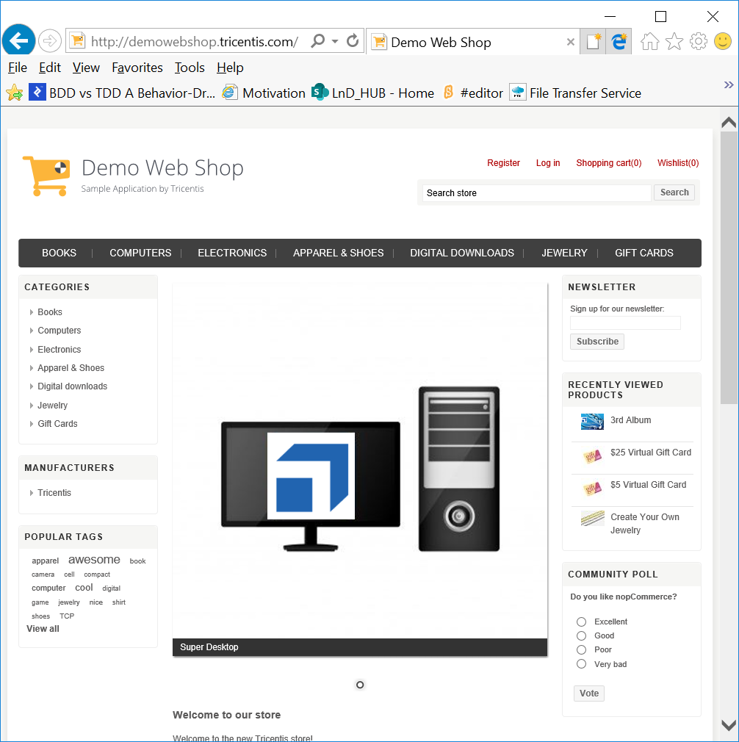
Fig : Home Page

3. Module-2 New User Registration

Expected Tasks :
- To validate the heading Registration.
- To validate that the Registration process by entering all mandatory and valid details.
- To validate on entering wrong mail id
- To validate by entering password less than required minimum length URL.
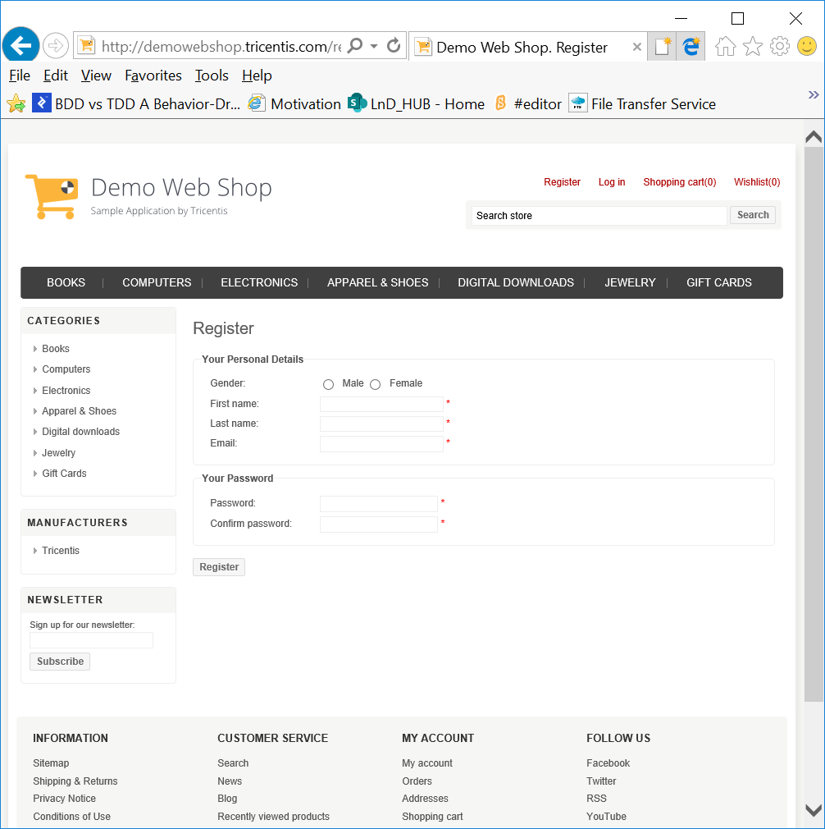
Fig : Register UI

4. Module-3 Login

Expected Tasks :
- To validate the Log in link.
- To validate Log in process with correct credentials
- To validate Forgot password? Link and check if you get the new password.
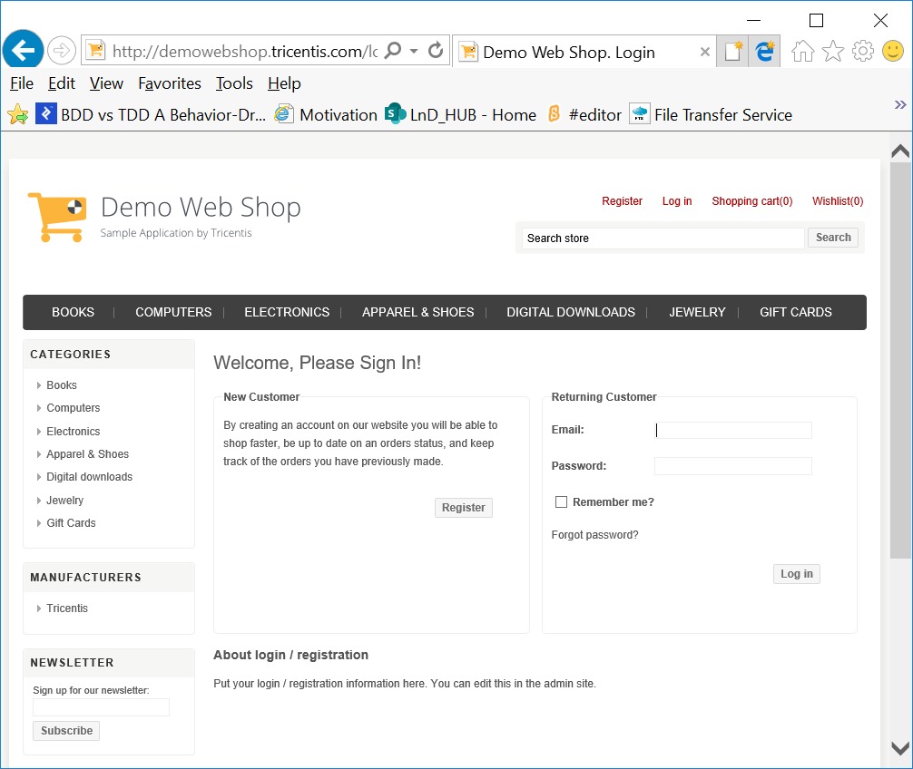
Fig : Login UI

5. Module-4 Browse & Search Product

Expected Tasks :
- To search for a specific product using Search Store
- To browse for products through Recently viewed Products
- To search for products through Popular Tags

6. Module-5 Shop & Add Product to Cart

Expected Tasks :
- To validate if user is able to navigate to various product categories from the menu.
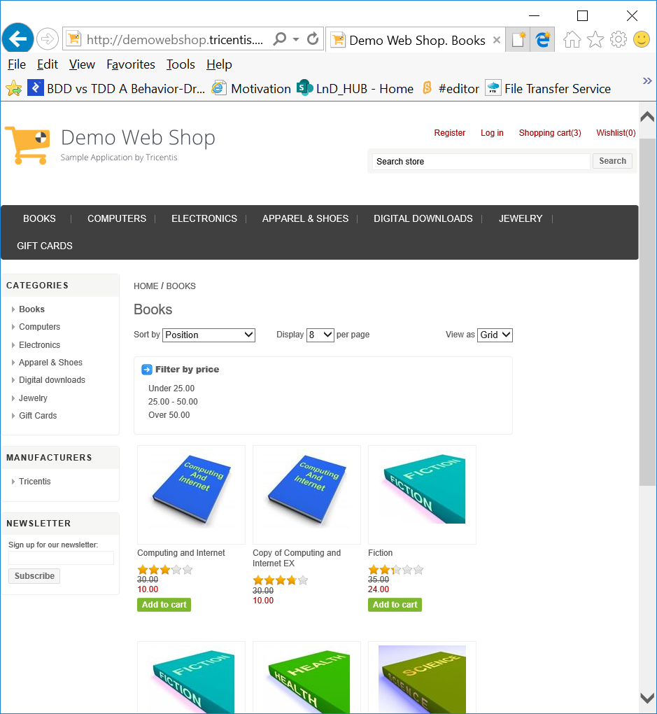
Fig : Product Category UI for Books

- Choose one of the product category
- To sort the products based on Sort by: Name A-Z or Z-A, Price as low to high or vice versa, Created On.
- To customize the display of products through Display No. of Products per Page
- To display the products in different formats through View as : List or Grid
- Select the product and Add to Cart.
- Check if the Shopping Cart is updated or not.
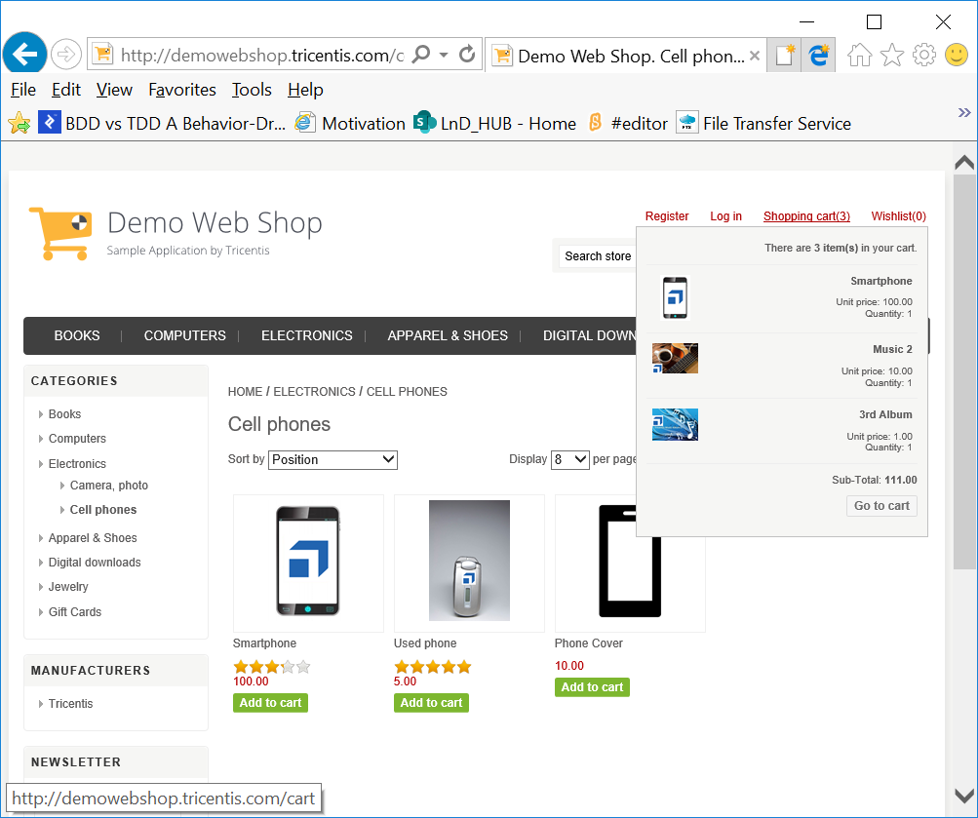
Fig : Shopping Cart dropdown showing the products added to the cart.

- Select few products and compare their prices and names using the link Add to Compare List
- Select few products and Add to Wish List. Check if the Wishlist is updated.
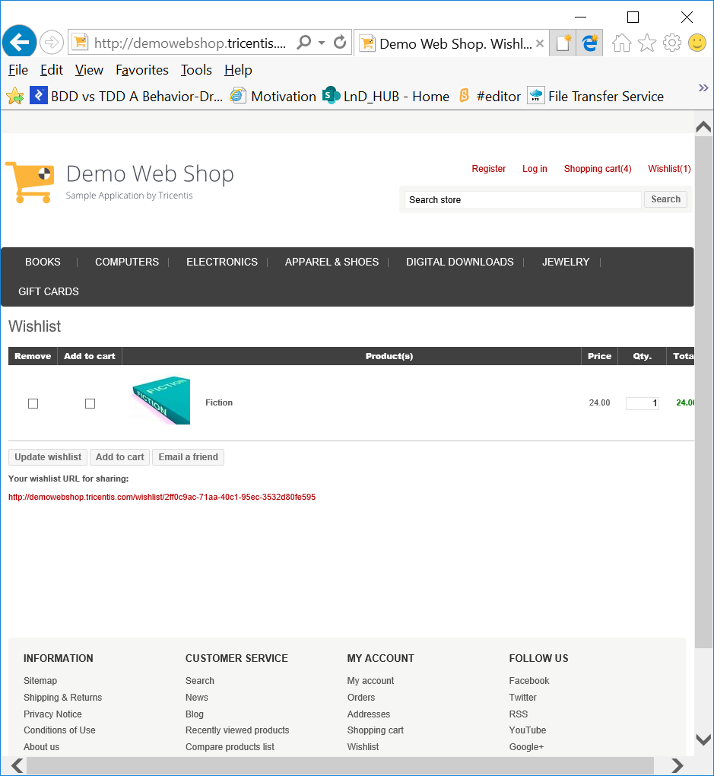
Fig : Wishlist

- From the Wishlist, add the product to Cart (or) remove if not required any more.

7. Module-6 Shopping Cart

Expected Tasks :
- Navigate to Shopping Cart
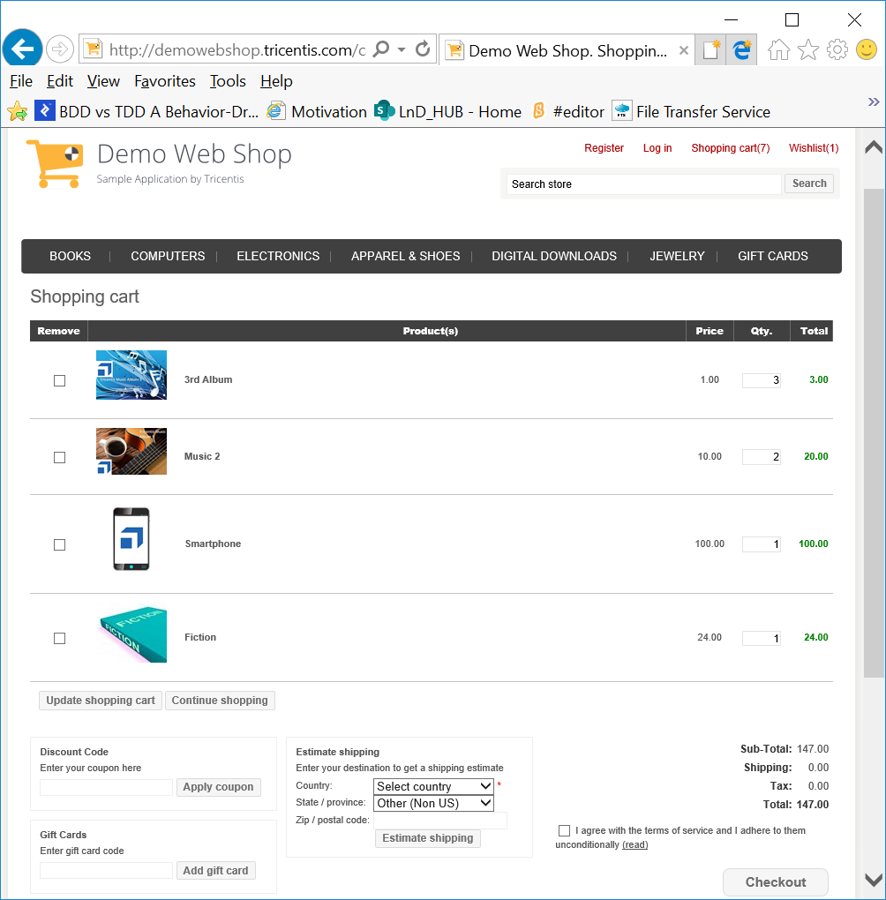
Fig : shopping Cart

- Check if you want to remove any products from the Cart.
- Edit the Quantity of the products and Update Shopping Cart
- Add a new product to the cart by navigating through Continue Shopping
- Try entering a Coupon code to get discount
- If you have selected the product ‘Gift Card’, enter the gift card code.
- Select/enter the details for Shipping and click Estimate Shipping to know the Shipping details.
- Click on Check Out to navigate to Payment page.
- Incase if you are not log-in in this process, you will be prompted to log-in.

8. Module-7 Check Out - Billing

Expected Tasks :
- You are navigated to Billing Page on Check out.
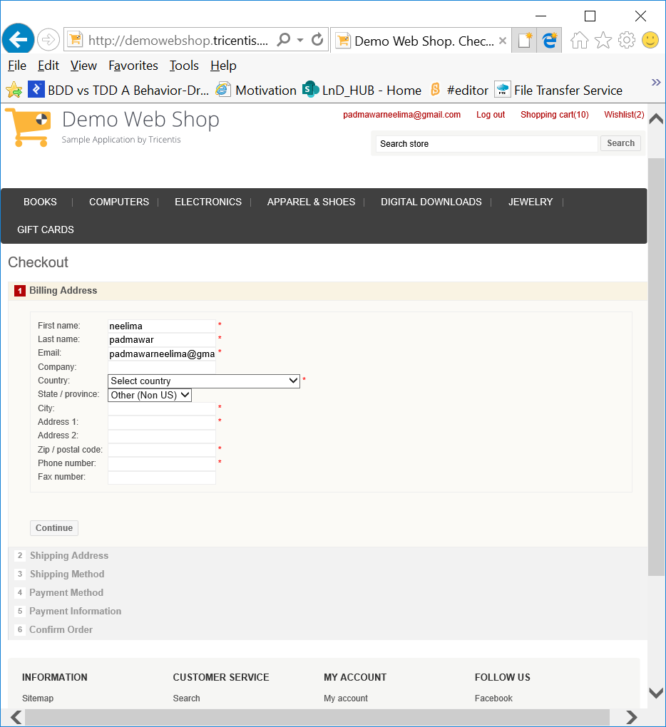
Fig : Billing

- Enter all the mandatory and valid details
- Check the alert/suitable messages on not entering mandatory details
- Check the alert/suitable messages on not entering valid details.
- Click Continue
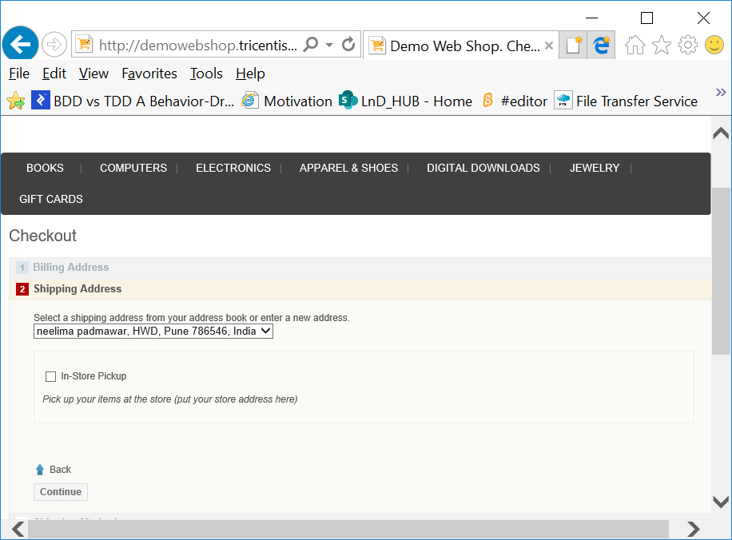

- Click Continue and select required Shipping method
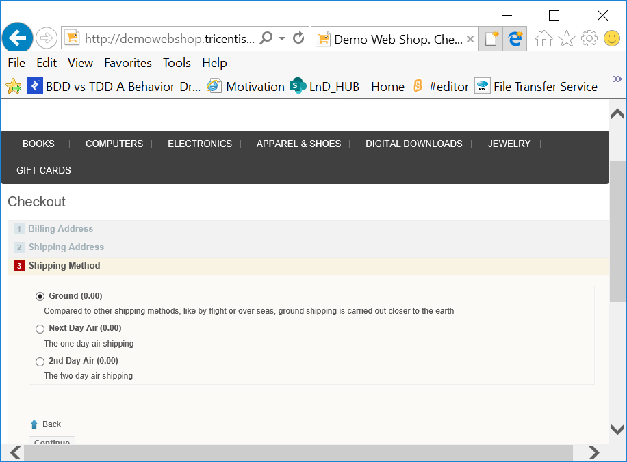
- Select Payment method
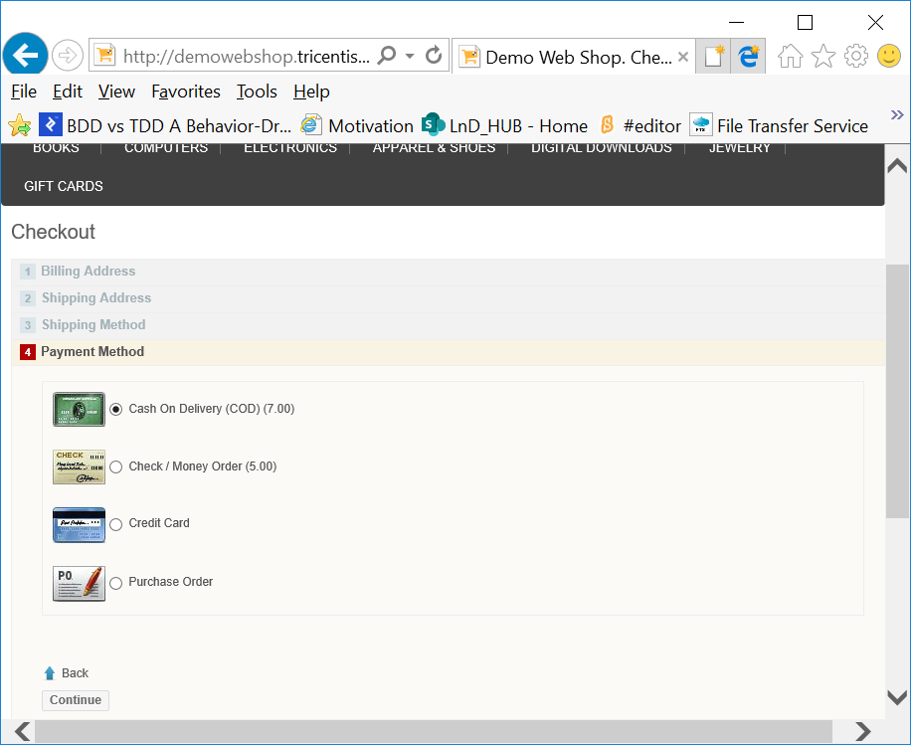
- Click Continue
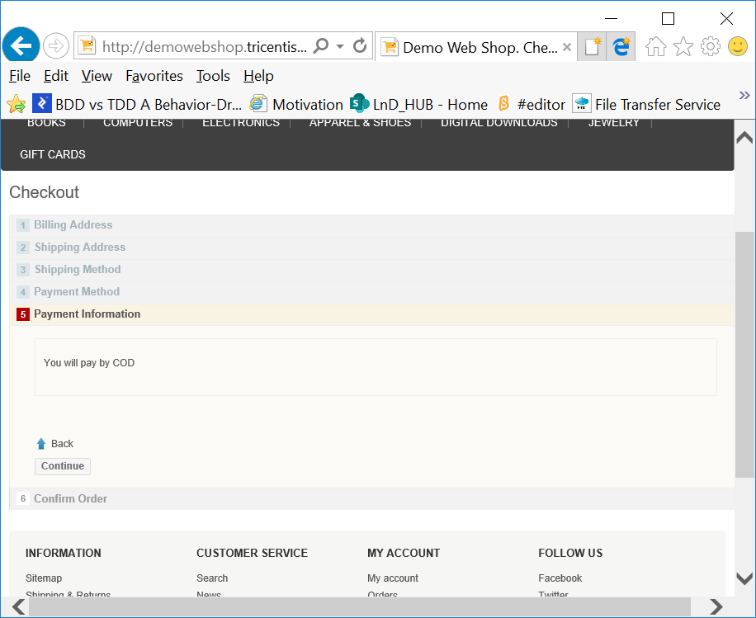
- Click Continue
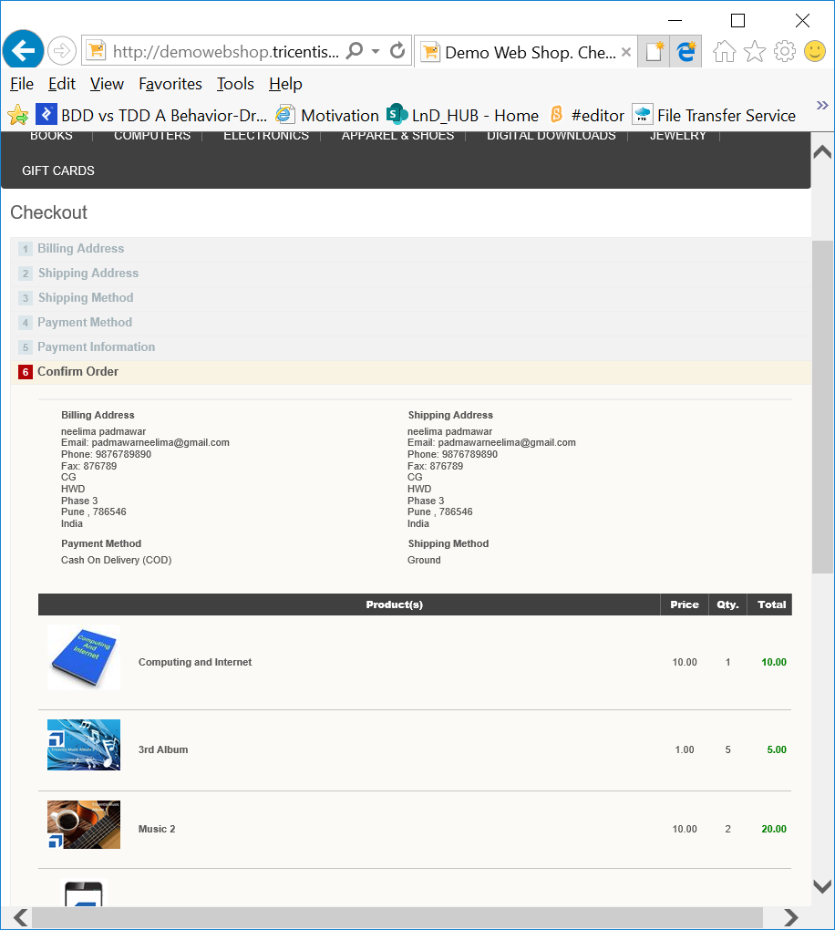
- Confirm Order
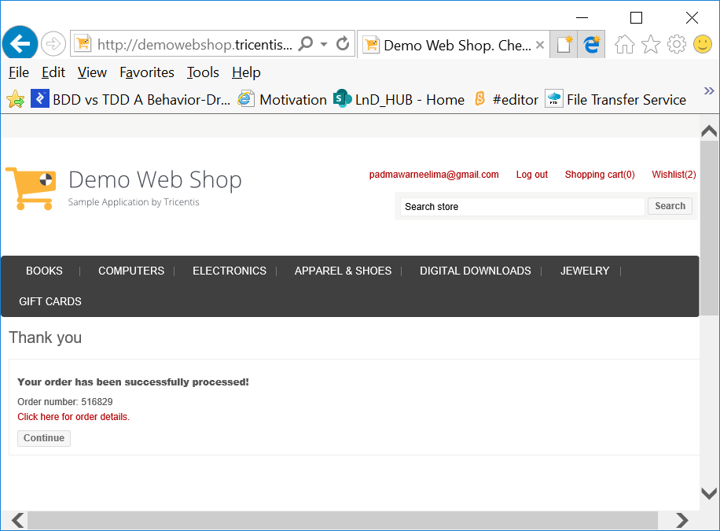
- Check the Order details by clicking on ‘Click here for Order details
